EXPERIMENT NO: 2
SOLDERING & DESOLDERING PRACTICE
AIM:
To practice soldering of electronic components and desoldering.
MATERIALS AND TOOLS REQUIRED:
Solder, flux, knife/blade, soldering iron, desoldering pump and nose pliers.
THEORY:
Soldering is the process of joining two or more similar or dissimilar metals by melting another metal having low melting point.
Soldering fluxes: In order to make the surfaces accept the solder readily, the component terminals should be free from oxides and other obstructing films. Soldering flux cleans the oxides from the surface of the metal. The leads should be cleaned chemically or by scraping using a blade or a knife. Small amount of lead should be coated on the cleaned portion of the leads and the bit of the soldering iron. This process is called tinning. Zinc chloride, ammonium chloride and Rosin are the most commonly used fluxes. These are available in petroleum jelly as paste flux. The residues which remain after the soldering may be washed out with more water accompanied by brushing.
Solder: Solder is used for joining two or more metals at temperatures below their melting point. The popularly used solders are the alloys of tin (60%) and lead (40%) that melts at 375°F (190°C) and solidifies when it cools. Most of the solder wires are flux cored type. When such solder wires are used extra soldering flux is not required.
Soldering tools Soldering iron: It is the tool used to melt the solder and apply at the joints in the circuit. It operates in 230 V mains supply. The normal power ratings of the soldering iron are 10 W, 25 W, 65 W, and 125 W. The iron bit at the tip of it gets heated up within a few minutes. 10 W and 25 W soldering irons are sufficient for light duty works.
Desoldering: It is the removal of solder from a previously soldered joint. Desolder pump is a commonly used device for this purpose. When the solder melts by the action of the soldering iron, a trigger on the desolder pump should be activated to create a vacuum. This vacuum pulls the solder into the tube.
Rules of soldering:
- Select the proper soldering iron for the work.
- Tin the bit before soldering.
- Keep the tinned bit always cleans from oxide formed while soldering.
- Do not overheat the PCB and devices.
- Do not use excess solder or flux.
- Clean the surfaces of the leads to be joined using a blade.
PROCEDURE
- Plug in the chord of soldering iron into the mains supply to get it heated up.
- Clean the component leads using a blade or a knife and bends them according to the needs. Apply a little flux on the leads. Take a little solder on soldering iron and apply the molten solder on the leads. Care must be taken to avoid the components getting heated up.
- Mount the components on the PCB, apply flux on the joints and solder the joints. Soldering must be done in minimum time to avoid dry-soldering and heating up of the components.
- Wash the residues using water and brush.
- Practice desoldering a soldered circuit, using soldering iron and the desolder pump.
RESULT
Soldering and desoldering was performed on dot-type PCB.

EXPERIMENT NO:3
CENTRE TAPPED FULLWAVE RECTIFIER WITH REGULATOR (REGULATED POWER SUPPLY)

AIM:
To design and set up a 5V regulated power supply on a PCB and verify its output voltage
COMPONENTS AND EQUIPMENT’S REQUIRED:
Step down transformer 6-0-6 1no
Diodes 1N4001/4007 2nos
Resistor 100Ω 2nos
1K 1 no
Capacitor 220uF 1no
Zener diode 5.1V 1no
PCB, Soldering iron, solder, Flux, connecting wires, Multimeter
THEORY:
The first building block in the dc power supply is a step down transformer: is one whose secondary voltage is less than its primary voltage. Second block is the full wave rectifier. The purpose of the full wave rectifier (FWR) is to create a rectified dc output from a sinusoidal ac input signal. Here we use centre tapped full wave rectifier. In such a rectifier, the ac input is applied through a transformer, the anodes of the two diodes D1 and D2 are connected to the opposite ends of the centre tapped secondary winding and two cathodes are connected to each other and are connected also through the load resistance R and back to the centre of the transformer, as shown. During the positive half-cycle of the supply, the anode of diode D1 is positive w.r.t. cathode, and anode of diode D2 is negative w.r.t. cathode. Thus only diode D1 conducts, being forward biased and current flows from cathode to anode of diode D1 through load resistance R and top half the transformer secondary making cathode end of load resistance R positive. During the negative half-cycle of the input voltage the polarity is reversed, making the bottom of the secondary winding positive w.r.t. centre tap and thus diode D2 is forward biased and diode D1 is reverse biased. Consequently during this half-cycle of the input only the diode D2 conducts and current flows through the load resistance RL and bottom of the transformer secondary make the cathode end of the load resistance RL positive. Thus the direction of flow of current through the load resistance RL remains the same during both halves of the input.
Smoothing is performed by a large value electrolytic capacitor connected across the DC supply to act as a reservoir, supplying current to the output when the varying DC voltage from the rectifier is falling. The capacitor charges quickly near the peak of the varying DC, and then discharges as it supplies current to the output. Smoothing is not perfect due to the capacitor voltage falling a little as it discharges, giving a small ripple voltage. A larger capacitor will give less ripple. After the ripples have been smoothed or filtered from the rectifier output, we get a sufficiently steady DC output. To improve the constancy of the dc output voltage as the load and/ or the ac input voltage vary, a voltage regulator circuit is used. For low current power supplies a simple voltage regulator can be made with a resistor and a zener diode connected in reverse as shown in the diagram. The simplest regulator circuit consists merely of a resistor Rs connected in series with the filter capacitor and the zener diode connected in parallel with the load resistance RL. When the zener diode operates in its break down region, the voltage across it remains fairly constant even through the current flowing it may vary considerably.
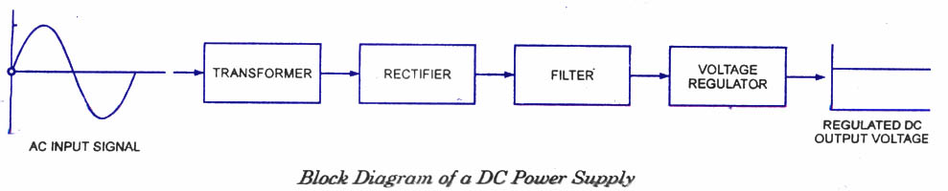

CIRCUIT DIAGRAM
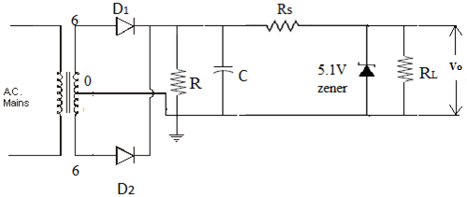
DESIGN
Output requirements Vo=5V, IL= 50mA
Select 230 V/6 V- 0- 6 V, 50mA center tapped transformer
Select diode 1N4001 0r 1N4007
Load resistor R_{L} should be high enough to make the capacitor discharges slowly. Same time it should limit the current through the diodes.
Select R_{L} =1K
Select high capacitance; here C=220uF
For a given ripple factor (r),
Ripple factor of a full wave rectifier (r)= 1/4 R_{L} fC ; f=50Hz , R_{L} =load resistance, C= capacitance
C=1/(r*4 R_{L} f)
R_{s}= V_{m}-Vo/(Iz+I_{L})
V_{m}=6= 8.4V (as we used 6-0-6 step down transformer)
V_{o}=V_{Z}=5.1V
Given Load current I_{L} =50mA & Assume zener current I_{Z}=10mA
R_{s}= 8.4-5.1/(50+10)mA=56.4 Ω
take R_{s}=100Ω
And R_{L}=V_{o}/I_{L}= 5.1/50mA=102 Ω
Take R_{L}=100Ω
PROCEDURE:
Trace the circuit diagram of a regulated power supply on a PCB with reference to the circuit diagram. Connect the primary of the transformer to the AC mains. The output of the circuit is connected to the multimeter. Observe the output voltage.
RESULT:
A regulated power supply circuit was setup on a PCB and verified its output voltage.
Output voltage= ------ V

EXPERIMENT NO: 4
CATHODE RAY OSCILLOSCOPE

AIM: To study the CRO and measure the frequency and amplitude.

APPARATUS: CRO, Function generator.

THEORY: The cathode ray oscilloscope (CRO) is a very useful and versatile laboratory instrument used for display, measurement and analysis of waveforms and other phenomenon
in electrical and electronics circuits. Cathode ray oscilloscope is one of the most useful electronic equipment, which gives a visual representation of electrical quantities, such as voltage and current waveforms in an electrical circuit. It utilizes the properties of cathode rays of being deflected by an electric and magnetic fields and of producing scintillations on a fluorescent screen.

A CRO consists of the following parts.
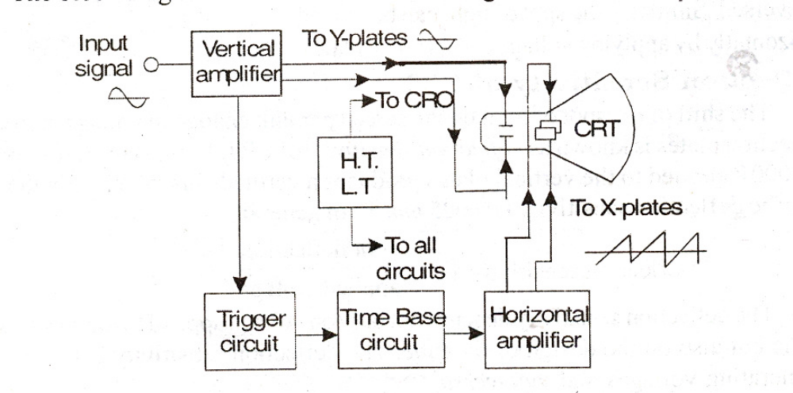
CRT: To produce high intense pencilled beam on its fluorescent screen.

Vertical Amplifier: To amplify electrically the electrical wave form to be viewed through ‘Y’ plates of CRT.

Horizontal Amplifier: To amplify the wave form to be displayed through X plates of CRT, which is internally connected through time base saw-tooth voltage (sweep voltage) if desired through a control switch for display of a signal wave form.

Sweep Generator: To produce sweep voltage on X-plates if desired as above.

Trigger Circuit: To start horizontal sweep or time base voltage.

HT and LT supply: High tension (or voltages) and low tension (or voltages) desired at different points in CRT, horizontal and vertical amplifiers, sweep generator etc., in the whole assembly of CRO. There are other provisions on front panel of CRO such as intensity control, focus control, horizontal control and vertical control

PROCEDURE: To study the waveforms, it is fed to the y – plates or X-plates. The size of the figure displayed on the screen, can be adjusted suitably by adjusting the gain controls. The time frequency can be changed, so as to accommodate one, two or more cycles of the signal. There is a provision in C.R.O to obtain a sine wave or a square wave or a triangular wave.

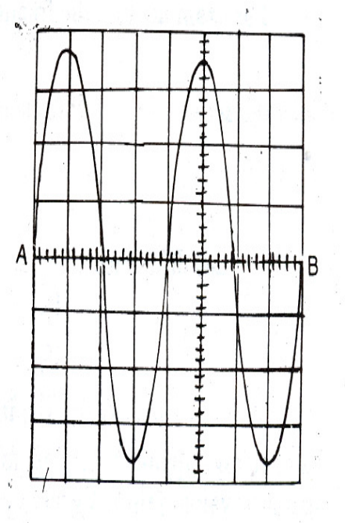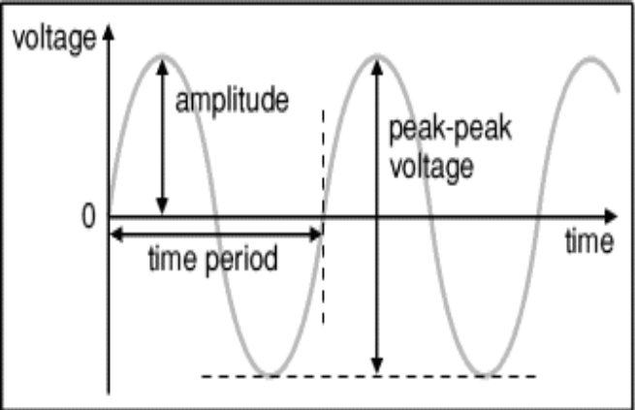

FIG 1: Frequency on CRO screen FIG 2: Amplitude on CRO screen

CRO FRONT PANEL CONTROL & THEIR FUNCTIONS

1. | POWER | Push it down to connect the power and the indicator is ON.
2. | INTENSITY | Adjust the intensity and turn it clockwise, the trace is brightened.
3. | FOCUS | Adjust the focus of CRT and make it be a small and clear dot.
4. | TRACE ROTATION | Adjust the trace to be parallel with the horizontal scale.
5. | PROBE ADJUST | One square wave signal with amplitude of 0.5V and the frequency of 1KHz is output from the terminal and used to adjust the Y axis deflection factor and sweep time factor.
6. | AC ┴ DC | Select the inputting coupling mode of vertical channel 1. AC: DC part of the signal is separated then AC part can be observed; DC: the signal is coupled directly with the channels to observe the DC part of the signal or when the frequency of the measured signal is very low. GND is grounded to determine the trace position when the input terminal is of Zero level.
7. | CH1(X) | Has two functions It can be used as the input terminal of vertical channel 1 in normal use and it also can be used as the signal input terminal of horizontal channel in XY mode.
8. | VOLTS/DIV | Select the vertical deflection factor. Altogether 12 steps from 5mV/div. Select the proper step according to the voltage amplitude of the measured signal.
9. | VARAIBLE | Adjust the vertical deflection factor continuously. The range is no less than 2.5times. Turn it to the end clockwise to make it be in the calibrated position. Then the voltage value can be read out by the position of Volts/Div.
10. | PULL ×5 | Push it down and the gain is magnified to 5 times.
11. | POSITION | Adjust the trace position vertically.
12. | MODE | Select the working mode in the vertical system.  CH1: Signal on CH1 are displayed only.  CH2: Signal on CH2 are displayed only.  ALT: Observe signals from two channels at the same time. The signals are displayed alternately. The mode is usually used at high sweep rate.  CHOP: The signals from two channels are displayed in chopping mode. It is used to observe the signals at the same time at low sweep rate.  ADD: Display the adding sum of the signals from two channels. When CH2 polarity is switched on, the two signals are subtracted.  CH2 Phase-Inversion: The signal on CH2 is normal when the knob is switched off and it would be phase inverted when the knob is switched on.
13. | AC ┴ DC | Used on CH2 and the functions are same as (6)
14. | CH2 PLUG | Input terminal of CH 2 and used as Y input when in X-Y mode
15. | POSITION | Adjust the trace position vertically
16. | CH2 SWITCH | Same as 8
17. | VARIABLE | Same as 9
18. | CH2 MAG | Same as 10
19. | POSITIONS | Same as 11
20. | SLOPE | Select the measured signal to be triggered in rising slope or in dropping slope.
21. | LEVEL | Adjust the measured signal to be triggered in one level.
22. | SWEEP MODE | Select the sweeping mode.  AUTO: Sweeping trace would display when there is no triggering signal; and there is one, it automatically changes to Trigger Sweep mode, then adjust LEVEL to make the waveform display on the screen stable. The mode is properly used to observe the signals with the frequency over 50Hz.  NORM: No trace to display when there is no triggering signals.0 if there is one and the LEVEL is in proper position, the circuit is triggered to sweep. It is used to observe signals with frequency lower than 50Hz.  LOCK: The waveform can be displayed stable on the screen without adjusting the LEVEL in LOCK mode.  SINGLE: Use to produce the single sweep. Push down the RESET and the circuit is in SINGLE mode. When there is a triggering signal, it will sweep for once, and the RESET should be pushed down for another sweep.
23. | TRIG’D READY | The indicator would be on in two cases: In non-single mode, it means that the sweep circuit is in triggered mode and in single mode: it means that the sweep circuit is ready, and then if there is one input signal, it will sweep for once and the indicator would be off.
24. | SEC/DIV | Select the proper step according to the frequency of the measured signals. When it is in VARIABLE the time factor be read out by the scale position and the distance between the wave in horizontal axis.
25. | VARIABLE | Adjust the sweep rate continuously and the range is no less than 2.5 times. Rotate it to the end clockwise to the calibrated position.
26. | MAG×10 | Push it down, then the horizontal sweep rate is magnified 10 times.
27 | SLOW SWEEP | Used to observe signal with low frequency.
28. | TRIGGER SOURCE | Used to select different trigger sources.  CH1: The trigger signal is from CH1 in DUAL and from the displayed channel in SINGLE.  CH2: The trigger signal is from CH2 in DUAL and from the displayed channel in SINGLE.  ALT: the trigger signal is alternatively from two Y channels in ALT to observe two signals from two irrelative channels.  POWER: The signal is from power.  EXT: The signal is from the input terminal.
29. | ┴ | The grounded end for the instrument.
30. | AC/DC | Coupling mode of external trigger signals. The switch should be in DC position when the external trigger source is selected and the frequency is very low.
31. | NORM/TV  TV-H, TV-V | Generally the switch is in NORM position and if TV signals are measured it should be in TV position. Combine two set TV-H, TV-V key, Let the signal of TV-h, TV-V trig synchronously.
32) | EXT INPUT | The trigger signal is input from the terminal.
33) | Z INPUT | For the signal for INTE modulating.
34) | TRIGGER SIGNAL OUTPUT | Output CH1 or CH2 signal of 100mV/div with the trigger signal and be convenient for external frequency counter.
35) | POWER PLUG WITH FUSE | For the power line of the instrument.

FREQUENCY AND TIME PERIOD MEASUREMENT:

1. Proper adjustment is made.
2. Apply the signal to Y-plates.
3. The time base control is adjusted to get waves (complete) on the screen.
4. The numbers of division for one complete cycle of the displayed waveform on X scale
represent its time period.
5. Time period =Time base setting *Horizontal displacement.
6. The frequency for a given waveform can be calculated from time period.
7. Frequency = 1/T Hz, where is T is the time period.
VOLTGE MEASUREMENT:
1. Voltage is shown on the vertical y-axis and the scale is determined by the Y amplifier
(volts/cm).
2. Usually peak-peak voltage is measured because it can be read correctly even if the position of 0V is not known.
3. The amplitude is half the peak-peak voltage.
4. To read the amplitude voltage directly you must check the position of 0V (normally halfway up the screen).
5. Move the AC/GND/DC switch to GND (0V) and use Y-SHIFT (up/down) to adjust the position of the trace if necessary, switch back to DC afterwards so you can see the signal again.
6. Count the number of division between Positive and Negative peaks.
7. Peak-Peak Voltage =Deflection amplitude*Volts / cm.
8. Amplitude (Peak Voltage) = ½ × peak-peak voltage

OBSERVATION TABLE:

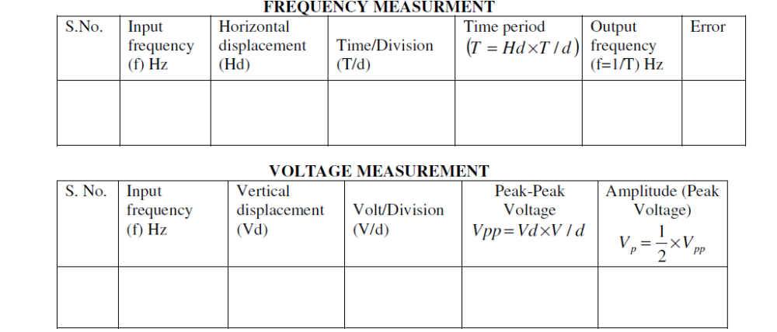

RESULT: The input and output frequencies are compared and voltage is found out.

EXPERIMENT NO :5
HALF WAVE RECTIFIER
AIM:
To study the characteristics of Half wave rectifier with and without filter and calculate its ripple factor
COMPONENTS AND EQUIPMENT’S REQUIRED:
Diode 1N4007 1no
Resistor 1K 1no
Step down transformer 6-0-6 1no
Breadboard, CRO, BNC probe, connecting wires etc....
THEORY:
Rectifier is a circuit used to convert AC to DC. The rectifier element used here is a PN diode. The diode conducts only when its anode is at a higher voltage with respect to cathode. In a half wave rectifier circuit, during positive half cycle of the input, the diode gets forward biased and conducts. The current flows through the load resistance R_{L} and voltage is developed across if. During negative half cycle of the input, the diode gets reverse biased. No current flow through the load resistance during this period of input cycle is zero. Thus a pure AC is converted to unidirectional signal. The main function of a filter circuit is to minimize the ripple content in the rectifier output. Certain electronic circuits need smooth DC voltage. A filter circuit does this function. In this circuit, a suitable single capacitor C is connected across the rectifier and in parallel with the load R_{L} to achieve the filter section. The property of the capacitor is that it does not allow any change in voltage across its terminals. When connected across a pulsating DC voltage, it tends to smoothen out or filter out the ripples in the output voltage of the rectifier.
Selection of capacitor C : (Sample Design)
Assume 10% of ripple factor.
We know r =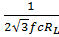
R_{L} = 500 Ω
Hence C =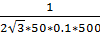 = 115μF ≈ 100μF
Voltage rating of the capacitor must be > V_{m}
Hence the capacitor selected for 10% ripple factor is 100μF, 16V

Calculation

Without filter

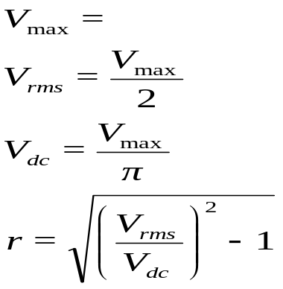
With filter

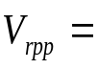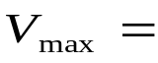
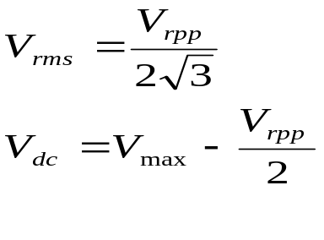
Ripple factor, r=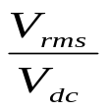

The theoretical value is given by the expression r=
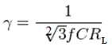

PROCEDURE:
- Wire the half wave rectifier circuit without capacitor after testing all components.
- Switch On mains supply. Observe the transformer secondary voltage waveform and output voltage waveform across the load resistor, simultaneously on the CRO screen. Note down the peak values.
- Calculate the ripple factor using the expression.
- Connect the capacitor filter and observe the waveforms. Note down V1 and V2 and calculate the ripple factor using the expression.

Circuit Diagram
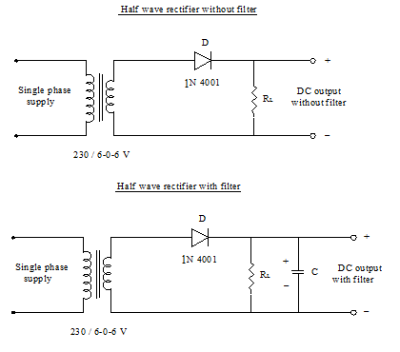

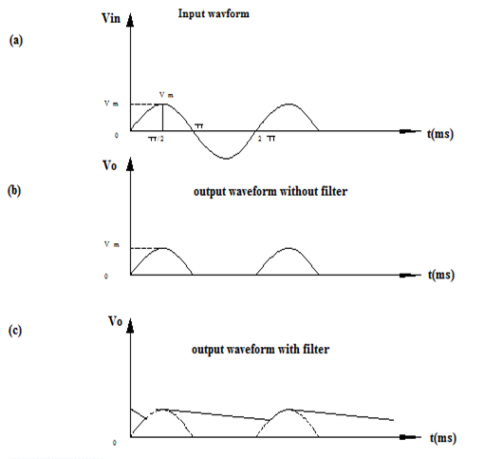
RESULT :
Ripple factor , r = (with filter)
= (without filter)

EXPERIMENT NO:6
FULL WAVE RECTIFIER (CENTER TAPPED)
AIM :
To study the characteristics of Full wave center tapped rectifier with and without filter and calculate its ripple factor
THEORY :
This full wave circuit comprise of two half wave circuits which are so connected that conduction takes place through one diode during one half of the power cycle and through the other diode during the second half of the power cycle. The current to the load which is the sum of these two currents conducted by the diodes at each half cycle. The peak inverse voltage in this case is 2 Vm, Vm – peak value of the voltage.
The output of full wave rectifier is pulsating, it has a dc value of magnitude 2V_{m}/π and some AC variations called ripples. Certain circuits need very smooth dc voltage. Hence the circuits that converts a pulsating output from a rectifier to a very steady dc level is known as filter, because it filters out or smoothens out pulsations in the output. Here a capacitor of suitable value C₁ connected across the rectifier and in parallel with the load R_{L} to achieve filtering action. This filter circuit depends on a property of capacitor that it opposes any change in voltage across its terminals. When connected across a pulsating DC voltage, it tends to smoothen out or filter out the voltage pulsations

Selection of capacitor C (Sample Calculation)
Assume 10% of ripple factor.
We know r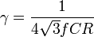L
R_{L} = 500 Ω
Hence C =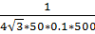 = 115μF ≈ 100μF
Voltage rating of the capacitor must be > V_{m}
Hence the capacitor selected for 10% ripple factor is 100μF, 16V
PROCEDURE
- The circuit is wired as in the circuit diagram.
- Connect the supply voltage to the primary of the centre-tapped transformer.
- Connect the output terminals to the CRO and observe the input- output waveform.
- Measure the DC voltage across the load resistor.
- Calculate the ripple factor and DC output voltage. Compare practical and theoretical results.

Circuit diagram
Rectifier without filter
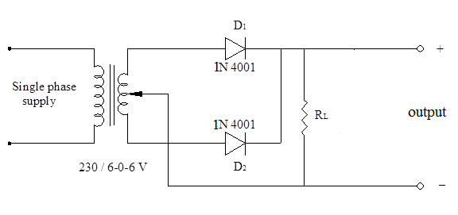
Rectifier with filter
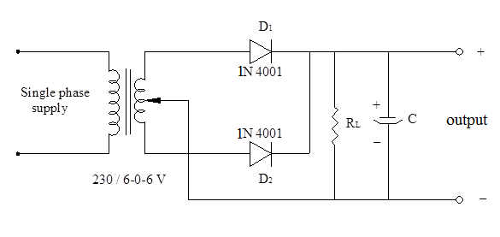

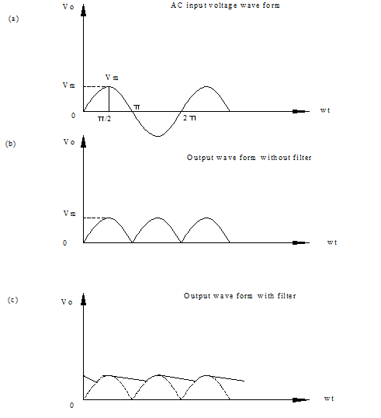

Calculation

With filter

V_{rms=}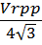
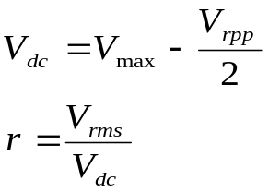

Without filter

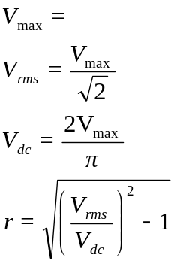

RESULT

Ripple factor , r = (with filter)
= (without filter)

EXPERIMENT NO :7
FULL WAVE RECTIFIER (BRIDGE RECTIFIER)
AIM :
To study the characteristics of Full wave Bridge rectifier with and without filter and calculate its ripple factor
THEORY
In a bridge configuration, the number of rectifier elements used is same as that used in full wave rectifier with centre tap.The principal features of bridge rectifier is
- Current in both the primary and secondary of the supply transformer flows for the entire ac cycle and hence for a given power output, power transformer of a smaller size is used in comparison with that of full wave rectifier.
- No centre tap is needed in the transformer secondary.
- Since two diodes are present in series in each conduction path, the peak inverse voltage is shared equally by the two diodes. Peak inverse voltage is V_{m}
Hence bridge rectifier is used for high voltage applications.
The output of full wave rectifier is pulsating, it has a dc value of magnitude 2V_{m}/π and some AC variations called ripples. Certain circuits need very smooth dc voltage. Hence the circuits that converts a pulsating output from a rectifier to a very steady dc level is known as filter, because it filters out or smoothens out pulsations in the output. Here a capacitor of suitable value C₁ connected across the rectifier and in parallel with the load R_{L} to achieve filtering action. This filter circuit depends on a property of capacitor that it opposes any change in voltage across its terminals. When connected across a pulsating DC voltage, it tends to smoothen out or filter out the voltage pulsations
Selection of capacitor C : (Sample Design)
Assume 10% of ripple factor.
We know rL
R_{L} = 500 Ω
Hence C = = 115μF ≈ 100μF
Voltage rating of the capacitor must be > V_{m}
Hence the capacitor selected for 10% ripple factor is 100μF, 16V
PROCEDURE :
- The circuit is wired as in the circuit diagram
- Connect the supply voltage to the primary of the transformer
- Connect the output terminals to the CRO and observe the input output waveform
- Measure the dc voltage at the input and output points
- Measure the dc voltage across the load resistor
- Calculate the ripple factor, dc output voltage

Circuit Diagram
Bridge F W R without filter
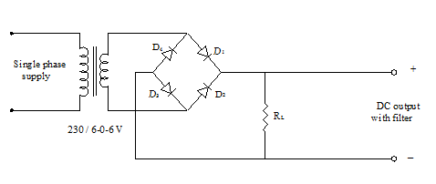

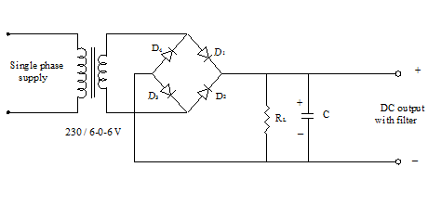
Bridge F W R with filter

Calculation

Without filter

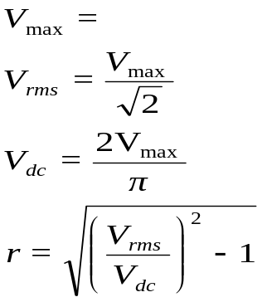

With filter

V_{rms=}

RESULT
Ripple factor , r = (with filter)
= (without filter)

EXPERIMENT 8
LED FLASHING CIRCUIT USING IC
AIM
Design and setup a LED flashing circuit using 555 timer
THEORY
An astable multivibrator, often called a free-running multivibrator, is a rectangular-wave generating circuit. Unlike the monostable multivibrator, this circuit does not require any external trigger to change the state of the output, hence the name free-running. An astable multivibrator can be produced by adding resistors and a capacitor to the basic timer IC, as illustrated in figure. The timing during which the output is either high or low is determined by the externally connected two resistors and a capacitor. Pin 1 is grounded; pins 4 and 8 are shorted and then tied to supply +Vcc, output (V_{OUT} is taken form pin 3; pin 2 and 6 are shorted and the connected to ground through capacitor C, pin 7 is connected to supply + V_{CC} through a resistor R_{A}; and between pin 6 and 7 a resistor R_{B} is connected. At pin 5 either a bypass capacitor is connected or modulation input is applied.
For explaining the operation of the timer 555 as an astable multivibrator, necessary internal circuitry with external connections are shown in figure.

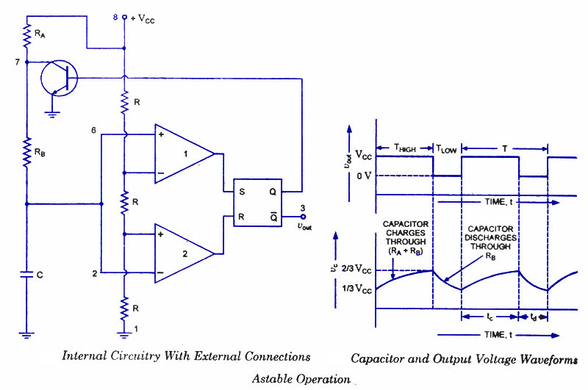
In figure, when Q is low or output V_{OUT} is high, the discharging transistor is cut-off and the capacitor C begins charging toward V_{CC} through resistances R_{A} and R_{B}. Because of this, the charging time constant is (R_{A} + R_{B}) C. Eventually, the threshold voltage exceeds +2/3 V_{CC}, the comparator 1 has a high output and triggers the flip-flop so that its Q is high and the timer output is low. With Q high, the discharge transistor saturates and pin 7 grounds so that the capacitor C discharges through resistance R_{B} with a discharging time constant R_{B} C. With the discharging of capacitor, trigger voltage at inverting input of comparator 2 decreases. When it drops below 1/3V_{CC}, the output of comparator 2 goes high and this reset the flip-flop so that Q is low and the timer output is high. This proves the auto-transition in output from low to high and then to low as, illustrated in fig ures. Thus the cycle repeats.
When power supply is switched on, capacitor C starts charging through R_{A} + R_{B}. At this instant, voltage at pin–2 is less than ⅓Vcc. So trigger comparator operates and pin–3 becomes high (i.e. 1) and pin–7 is cutoff. Hence, capacitor C starts charging. When voltage of capacitor C becomes equal to or greater than ⅔Vcc, the threshold comparator operates and pin–3 becomes low (i.e. 0). Now pin–7 becomes active and discharges the capacitor into itself through R_{B}only. In this way, capacitor C charges through R_{A} + R_{B} but discharges through R_{B} only. So charging time is greater than discharging time. In this process, the capacitor voltage rises and fall exponentially as shown in the wave diagram. Also, the output of IC becomes high during charging and becomes low during discharging. Hence, rectangular wave is obtained at the output.
Circuit Diagram
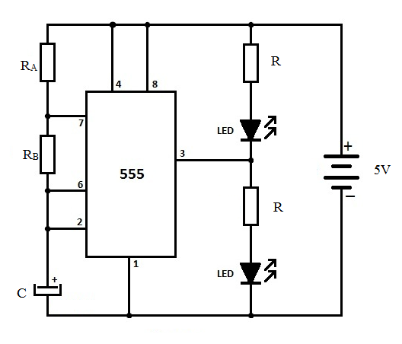
Design
The time during which the capacitor C charges from 1/3 V_{CC} to 2/3 V_{CC} is equal to the time the output is high and is given as
T_{HIGH} = t_{c} = 0.693 (R_{A} + R_{B}) C
where R_{A} and R_{B} are in ohms and C is in farads.
The time during which the capacitor discharges from +2/3 V_{CC} to +1/3 V_{CC} is equal to
the time the output is low and is given as

t_{d} or T_{L0W} = 0.693 R_{B} C

For T_{Low} =1 S

Take c=10uF
R_{B}=1/(0.693*1*10*10^-6)=144.3KΩ
Use R_{B}=150KΩ

For T_{High} =1 S

C=10uF and R_{B=}144.3KΩ
Calculation of R_{A}
T_{HIGH} = t_{c} = 0.693 (R_{A} + R_{B}) C
Use R_{A}=1.2MΩ
Design of current limiting resistor(R)
LED typically drops 1.8 volts & current 20 mA
R=(5-1.8)/20mA=160Ω
Use R=150Ω

Procedure
- The circuit is wired as in the circuit diagram
- Connect the supply voltage.
- The LED flashes.
- Verify the time period.

RESULT

EXPERIMENT 9
LED FLASHING CIRCUIT USING TRANSISTOR
AIM
Design and setup a LED flashing circuit using transistor.
THEORY
An Astable Multivibrator or a free running oscillator circuit is generally used to generate square waves for a specified time period. The name Astable Multivibrator is used for it because, it does not have a stable state and it switches between two quasi stable states. Consider the instant at which the DC supply is switched on. The collector terminal of T₁ is connected to the base of T₂ via a capacitor C₁ and similarly the collector terminal of T₂ is connected to the base of transistor T₁. So, due to this configuration only one transistor can remain switched-on at a time. The time period is determined by the capacitor connected to its base. At the time of providing supply to this circuit, any imbalance among the transistors can cause any one of the transistor to conduct more, let it be T₁ now. As T₁ turns on its collector potential will be V_{CE}sat which is approximately equal to 0.3v therefore the transistor T₂ will get a base potential less than the cutin voltage 0.7 and this prevents transistor T₂ from turning on. Now since the capacitor C₁ is connected in series with the base terminal of T₂, the capacitor charges to vcc through R_{C1} resistor. As the capacitor charges, the base voltage of T₁ increases exponentially and when it is more than 0.7 v, the T₂ turns on. But the collector voltage of T₂ drops to V_{CE}sat which in turn is connected to the base of T₁ and it drives T₁ to switched-off state. Now C₂ charges to vcc through Rc₂ resistor and when the base voltage of T₁ is more than 0.7v T₁ turns on and T₂ goes off . This regenerative action continues until the power supply is maintained. Thus the time period depends on the value of C₁ and C₂
Design of a simple practical Astable Multivibrator
Target:
To make an led glow for 2 sec and remain off for 1 sec
Component selection parameters
Choose supply voltage as 9v
Select transistor BC107 as it is commonly available in market
Design of R₁ and R₂
We know R=V/I,therefore R₁=(Vcc-VCEsat)/Ic
R₁=(9V-0.3V)/(2mA)=4.3K
we choose R₁=R₂=4.7K(standard)
Design of R_{C1} and R_{C2}
R_{C1} and R_{C2} are the base resistors . They should provide enough base current to keep the transistor in saturation.
Base current Ib=Ic/hfe (hfe or gain of BC 107 is about 100 from datasheet)
Ib=20uA
Consider an over driving factor of 5 such that the transistor will surely be in saturation
therefore Ib=5*20uA=0.1mA
R_{C}1=(Vcc-VCEsat)/Ib=83K
Choose R_{C1}=R_{C2}=82K standard
The above designed values of resistors will not change as long as the transistor and supply potential is not replaced.
Design of time interval of switching
The time period of switching is controlled by the design of capacitor C₁ and C₂
let off time t2=1sec
and on time t1=2sec
The time constant of a capacitor is given by T=R*C (where R is the resistor through which the capacitor charges)
For practical situations we consider an over driving factor 0.69 therefore T=0.69RC
From the above equation C₂=t2/(0.69*RC2)=17.67uF choose 15uF standard
Now C₁=t1/(0.69*RC1)=35.34uF choose 33uF standard
Design of current limiting resistor(R)
LED typically drops 1.8 volts & current 20 mA
R=(9-1.8)/20mA=360Ω
Use R=330Ω

Circuit Diagram
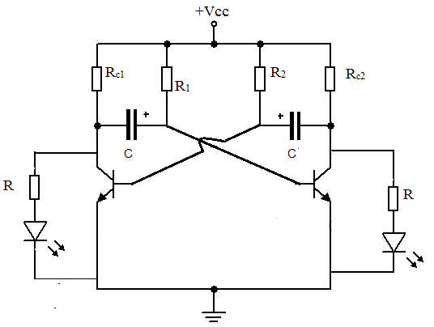
Procedure
- The circuit is wired as in the circuit diagram
- Connect the supply voltage.
- The LED flashes.
- Verify the time period.

Result

EXPERIMENT NO: 11
STUDY OF MULTIMETERS and TESTING OF COMPONENTS

AIM:
To study the use of multimeter to check voltage, current and also to check various electronic components.
THEORY:
A multimeter or a multitester, also known as a VOM (Volt-Ohm meter), is an electronic measuring instrument that combines several measurement functions in one unit. A typical multimeter would include basic features such as the ability to measure voltage, current, and resistance. Analog multimeters use a microammeter whose pointer moves over a scale calibrated for all the different measurements that can be made. Digital multimeters (DMM, DVOM) display the measured value in numerals, and may also display a bar of a length proportional to the quantity being measured. Digital multimeters are now far more common than analog ones, but analog multimeters are still preferable in some cases, for example when monitoring a rapidly-varying value. A multimeter can be a hand-held device useful for basic fault finding and field service work, or a bench instrument which can measure to a very high degree of accuracy. They can be used to troubleshoot electrical problems in a wide array of industrial and household devices such as electronic equipment, motor controls, domestic appliances, power supplies, and wiring systems.
PROCEDURE
DIGITAL MULTIMETER
Voltage Measurement
- Connect the red test lead to “V-Ω” input terminal and black test lead to “COM” input terminal.
- Set function/range switch to desired voltage type (DC/AC) and range. If magnitude of voltage is not known, set switch to highest range and reduce until a satisfactory reading is obtained.
- Turn-Off power to the device or circuit being tested and discharge all capacitors.
- Connect test lead to the device or circuit being measured.
- Turn On power to the device or circuit being measured. Voltage value will appear on the digital display along with the voltage polarity.
- Turn Off power to the device or circuit being tested and discharge all capacitors prior to disconnecting test leads.
Current Measurement
- Connect red test lead to the “mA” input terminal for current measurements upto 200mA. Connect black test lead to “COM” input terminal.
- Set function/range switch to desired current type (DC/AC) and range. If magnitude of curent is not known, set switch to highest range and reduce until a satisfactory reading is obtained.
- Turn-Off power to the device or circuit being tested and discharge all capacitors
- Open the circuit in which current is to be measured. Now securely connect test leads in series with the load in which current is to be measured.
- Turn-Off power to the device or circuit being tested
- Read current value on digital display.
- Turn Off power to the device or circuit being tested and discharge all capacitors
- Disconnect test leads from circuit and reconnect circuit that was being tested.
- For current measurement of 200mA or greater, connect the red test lead to “20A” input terminal & black test lead to the “COM” input terminal. If the resistance being measured is part of a circuit, turn off power to the circuit and discharge all capacitors.
Resistance Measurement
- Connect the red test lead to “V-Ω” input terminal and black test lead to “COM” input terminal
- Set function/range switch to desired “Ω” position. If magnitude of resistance is not known, set switch to highest range and reduce until a satisfactory reading is obtained.
- If the resistance being measured is part of a circuit, turn off power to the circuit and discharge all capacitors.
- Connect test leads to the device or circuit being measured. When measuring high resistance, be sure to connect adjacent points even if insulated, because some insulators have a relatively low insulation resistance, causing the measured resistance to be lower than actual resistance.
- Read resistance value on digital display. If a high resistance value is shunted by a large value of capacitance, allow digits to stabilize.
Diode and Transistor Measurements
DIODE TEST
- Connect the red test lead to “V-Ω” input terminal and black test lead to “COM” input terminal.
- Set function/range switch to diode test position.
- If the semiconductor junction being measured is a part of the circuit, turn off power to the circuit and discharge all capacitors.
- Connect test leads to the device.
- Read forward voltage value on digital display.
- If the digital display reads overrange(1), reverse the lead connection. The placement of test leads when forward reading is displayed indicates the orientation of the diode. The red test lead is positive and the black lead is negative. If overrange (1) is displayed with both lead connections, the junction is open. If a low reading (<1000) is obtained with both lead connection, the junction is shunted by a resistance <1KΩ. In the latter case the junction must be disconnected from the circuit inorder to verify its operation.
TRANSISTOR JUNCTION TEST
- Bipolar transistors can be tested in the same manner as diode, junctions formed between the base and emitter and the base and collector of the transistor. Measurement between the collector and emitter also should be made to determine if a short is present.
TRANSISTOR hFE MEASUREMENT
- Transistor must be out of circuit. Set function/range switch to hFE position.
- Plug the emitter, base and collector leads of the transistor into the correct holes in either the NPN or the PNP transistor test socket, whichever is appropriate for the transistor being checked. Read the hFE (beta or DC current gain) in the display.

CONTINUITY MEASUREMENTS
- Set the selector switch to the 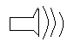 position.
- Continuity between probe tips will be indicated by an audible beep when resistance is below 100Ω.

Analog Multimeter
DCV measurement
- Connect red test probe to positive jack (+), while black to the COM jack(COM).
- Set the function switch to the appropriate Dc voltage range. If the voltage is unknown, use the highest range, exp.1200V. If the voltage applied falls within the range of a lower setting, reset the function/range switch to the appropriate setting for greater accuracy and to avoid the damage of the unit.
- Connect the red test lead to the circuit under test positive jack, while the black to the Negative jack, then the voltage value can be read on the scale.
- When read the value in the scale, please choose the scale of ‘DCV.A’ range according to the chosen range, eg. Choose 0~12 if the range is 12V, 120V, 1200V, choose 0~30 if the range is 0.3V, 3V, 30V, 300V.
ACV Measurement
- Connect red test lead to positive jack (+),the black test leads to the COM jack(COM).
- Set the function switch to the appropriate “ACV” range. If the voltage is unknown, use the highest range, exp.1200V. If the voltage applied falls within the range of a lower setting, reset the function/range switch to the appropriate setting for greater accuracy and to avoid the damage of the unit.
- Either red or black test leads can be connected to the circuit or components under test. With AC voltage, the polarity of the test leads is not a factor.
- When read the value in the scale, please choose the scale of “ACV” range according to the chosen range, eg: Choose 0~12 if the range is 120V, 1200V. Choose 0~30 if the range is 30V, 300V. 0~6 if the range is 6V.

DCC Measurement (DC mA) measurement
- Connect red test lead to positive jack (+),the black test leads to the COM jack(COM).
- Set the function switch to the appropriate “DC (mA)” range. If the value is unknown, use the highest range, eg 300mA and make the following measurement with the lower range accordingly.
- Connect the red test leads to input jack of the circuit or components under test, while the black is connected to output jack.
- When read the value in the scale, please choose the scale of “DCV.A” range according to the chosen range, eg: choose 0~60 if the range is 60µA, choose 0~30 if the range 3mA, 30mA, 300mA.
DC 12A measurement
- Connect the red test lead to DC current 12A input jack of the circuit or components while connect the black test lead to output jack.
- Set the function switch to “DC 12A” of range.
- Choose 0~12 scale when in the range of DCV.A, then the value can be read.
OHM Measurement
- Connect red test lead to positive jack (+),the black test leads to the COM jack(COM).
- Set the function switch to the “Ω” range. Select the appropriate range, ×10 ~×10K.
- Short the test leads together, using the zero Ω adjustment dial, slowly turn the dial until the needle indicator reads 0Ω at the right end of the Ωscale.
- For resistance testing, POWER MUST BE OFF, and make sure all the components with electricity must be discharged. Eg: capacitance.
- The resistance can be read when the black or red test leads connected to both terminals of circuits under test.
- Measure the value of the reading on the ohm scale and multiply the reading range. Eg: when in the range of ×1K, the needle point to 20, the actual value is 20×1000=20KΩ.
Continuity (BUZZ) Measurement.
- Connect red test lead to positive jack (+),the black test leads to the COM jack(COM).
- Set the function/range switch to the continuity range.
- For resistance testing, POWER MUST BE OFF, and make sure all the components with electricity must be discharged. Eg: capacitance.
- When the test leads connected to the circuit under test, the buzzer will sound when the ohm value is below 120Ω.
hFE testing
- Connect red test lead to positive jack (+),the black test leads to the COM jack(COM).
- Set the function/range switch to hFE (×10) in the range of “Ω”
- Short the test leads together, using the 0 Ω adjustment dial, slowly turn the dial until the needle indicator reads 0Ω at the right end of the Ωscale.
- Insert NPN or PNP transistor under test into the transistor socket of the unit.
- In the scale if hFE current amplification can be read directly.
DIODE TESTING
- Connect red test lead to positive jack (+),the black test leads to the COM jack(COM).
- Set the function/range switch to “Ω”. Set the appropriate function 150mA(×1), 15mA(×10), 1.5mA(×100), 150µA(×1K).
- Short the test leads together, using the zero ohms adjustment dial, slowly turn the dial until the needle indicator reads 0 ohms at the right end of the ohms scale.
- When the positive current of the transistor, connect the red test lead to the anode terminal of transistor, connect the black test lead to the cathode terminal of the transistor. When test reverse current of the transistor, the connect way should be reversed.
- In the scale of LI, the value of IF or IR can be read in the meantime, in the scale of low voltage (LV) the positive voltage (VF) or negative voltage (VR) can be read.

Result
The meters were studied and the components were tested.

