INTRODUCTION

Conditions like heavy load and line faults can cause the mains supply to sag or surge without warning. This can damage the appliances and equipment powered by the mains supply, unless these are automatically switched off by a protection device like the mains monitor presented here.
This mains monitor continuously monitors the mains voltage and immediately disconnects power to the load if the mains voltage goes beyond the predefined limit. As the mains power returns to its normal voltage, it reconnects the load after a preset time delay. Also, it tells whether a mains disruption occurred while you were out. The acceptable voltage range and the time taken before the power is restored to the load can be set by the user.

ABSTRACT

The aim of our project is to design a circuit that prevents damage to appliances connected to supply mains during voltage fluctuations. The power supply section provides 12V output. The LED display section indicates the supply voltage depending on transformer output. If voltage is within the range set by user, the Timer IC gets enabled and laod gets connected to supply mains through Relay after a preset time delay. If voltage goes out of the range, then Timer IC is disabled, NAND gate is enabled and Relay de energises to disconnect the load from supply mains.

BLOCK DIAGRAM

POWER SUPPLY

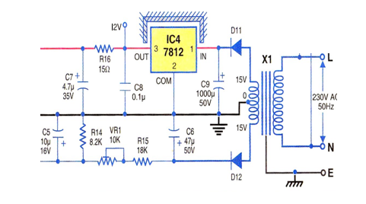

To derive the power supply for the circuit, the-230V AC mains is stepped down by transformer XI to deliver a secondary output of 15V-0-15V, 1A. The transformer output is rectified by two separate half-wave rectifier diodes D11 and D12. The rectified output from diode D11 is filtered by capacitor C9 and regulated by IC 7812 (IC4). Capacitor C8 bypasses the ripples present in the regulated supply. The filter stage made of resistoR.R16 and capacitor C7 provides a clean DC supply to the circuit.

LED DISPLAY

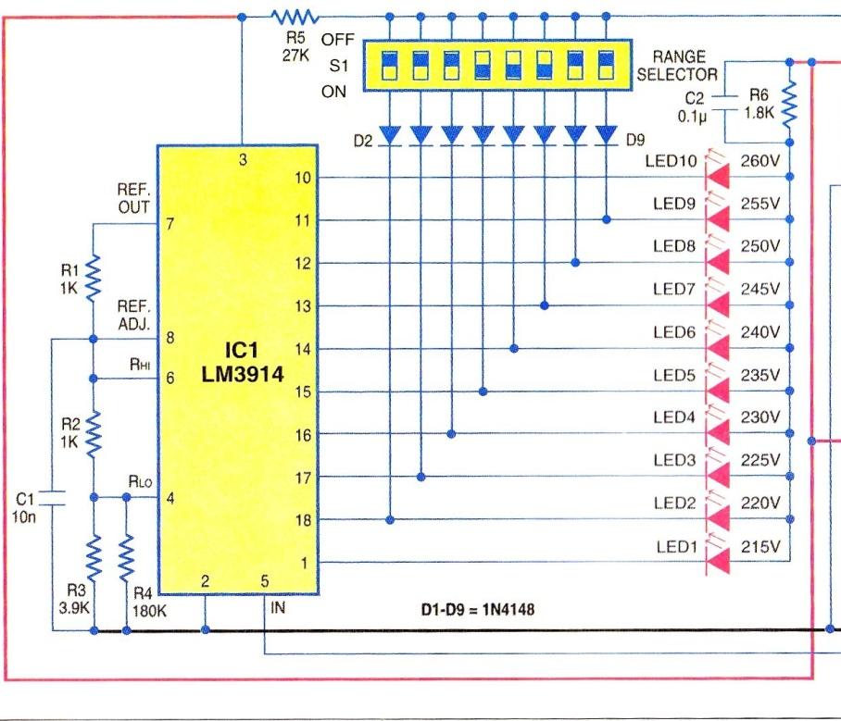

The rectified output of diode D12 is used to monitor the mains voltage level. It is filtered by capacitor C6 and applied to an adjustable voltage divider formed by resistor R15, preset VR1 and resistor R14. The adjustable voltage divider output is filtered by capacitor C5 and fed to input pin 5 of IC1. The voltage divider formed by resistors R1 through R4 makes IC1 act as a voltmeter. LED1 through LED10 glow as the input voltage at pin 5 of IC1 increments. Using resistors R1 through R4, IC1 is set to display 215V AC and 260V AC on LED1 and LED10, respectively. Pin 9 of IC1 is left open to make it run in 'dot' mode. Resistor R6 limits the current through LEDs.

Pins 11 through 18 of IC1 are coupled to diodes D2 through D9. Diodes D2 through D9, DIP switch SI and pull-up resistor R5 form an AND gate at the junction of resistor R5 and DIP switch SI. If the voltage-range selector DIP switches connected to D5, D6 and D7 are closed, the AND gate output will be low and LED5, LED6 and LED7 glow to indicate that the mains voltage ranges between 235V and 245V the acceptable voltage range.

TIMER
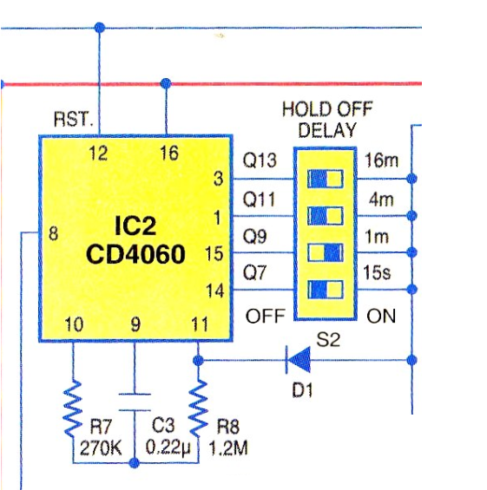

Timer IC2 is enabled when mains voltage is within the predefined range but resets when the mains voltage goes out of the acceptable limit. Resistors R7 and R8, and capacitor C3 run the internal oscillator of IC2 so that outputs Q7, Q9, Q11 and Q13 provide a time delay of 15 seconds, 1 minute, 4 minutes and 16 minutes, respectively.

OSCILLATOR

An oscillator is a mechanical or electronic device that works on the principles of oscillation: a periodic fluctuation between two things based on changes in energy. Computers, clocks, watches, radios, and metal detectors are among the many devices that use oscillators.

A clock pendulum is a simple type of mechanical oscillator. The most accurate timepiece in the world, the atomic clock, keeps time according to the oscillation within atoms. Electronic oscillators are used to generate signals in computers, wireless receivers and transmitters, and audio-frequency equipment, particularly music synthesizers. There are many types of electronic oscillators, but they all operate according to the same basic principle: an oscillator always employs a sensitive amplifier whose output is fed back to the input in phase. Thus, the signal regenerates and sustains itself. This is known as positive feedback. It is the same process that sometimes causes unwanted "howling" in public-address systems.

The frequency at which an oscillator works is usually determined by a quartz crystal. When a direct current is applied to such a crystal, it vibrates at a frequency that depends on its thickness, and on the manner in which it is cut from the original mineral rock. Some oscillators employ combinations of inductors, resistors, and/or capacitors to determine the frequency. However, the best stability (constancy of frequency) is obtained in oscillators that use quartz crystals

An electronic oscillator is an electronic circuit that produces a repetitive electronic signal, often a sine wave or a square wave. They are widely used in many electronic devices. Common examples of signals generated by oscillators include signals broadcast by radio and television transmitters, clock signals that regulate computers and quartz clocks, and the sounds produced by electronic beepers and video games.

Oscillators are often characterized by the frequency of their output signal: an audio oscillator produces frequencies in the audio range, about 16 Hz to 20 kHz. An RF oscillator produces signals in the radio frequency (RF) range of about 100 kHz to 100 GHz. A low-frequency oscillator (LFO) is an electronic oscillator that generates a frequency below ≈20 Hz. This term is typically used in the field of audio synthesizers, to distinguish it from an audio frequency oscillator.
RELAY

When AC mains is within the acceptable range (set by using DIP switch SI), the AND gate output is low, gate N4 output is high and LED12 is off. In short, when the AND gate output is low, the event memory flip-flop resets and relay RL1 energises to connect mains power to the load.

When the mains voltage goes outside the acceptable range, the resulting high level on the AND gate resets IC2 (making all of its outputs low). Transistor T1 cuts off and relay RL1 de-energises to disconnect the load from the mains

A relay is an electrically operated switch. Many relays use an electromagnet to operate a switching mechanism mechanically, but other operating principles are also used. Relays are used where it is necessary to control a circuit by a low-power signal (with complete electrical isolation between control and controlled circuits), or where several circuits must be controlled by one signal. The first relays were used in long distance telegraph circuits, repeating the signal coming in from one circuit and re-transmitting it to another. Relays were used extensively in telephone exchanges and early computers to perform logical operations.
A type of relay that can handle the high power required to directly control an electric motor or other loads is called a contactor. Solid-state relays control power circuits with no moving parts, instead using a semiconductor device to perform switching. Relays with calibrated operating characteristics and sometimes multiple operating coils are used to protect electrical circuits from overload or faults; in modern electric power systems these functions are performed by digital instruments still called "protective relays".

Basic design and operation
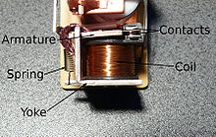

Small "cradle" relay often used in electronics. The "cradle" term refers to the shape of the relay's armature.

A simple electromagnetic relay consists of a coil of wire wrapped around a soft iron core, an iron yoke which provides a low reluctance path for magnetic flux, a movable iron armature, and one or more sets of contacts (there are two in the relay pictured). The armature is hinged to the yoke and mechanically linked to one or more sets of moving contacts. It is held in place by a spring so that when the relay is de-energized there is an air gap in the magnetic circuit. In this condition, one of the two sets of contacts in the relay pictured is closed, and the other set is open. Other relays may have more or fewer sets of contacts depending on their function. The relay in the picture also has a wire connecting the armature to the yoke. This ensures continuity of the circuit between the moving contacts on the armature, and the circuit track on the printed circuit board (PCB) via the yoke, which is soldered to the PCB.

When an electric current is passed through the coil it generates a magnetic field that activates the armature, and the consequent movement of the movable contact(s) either makes or breaks (depending upon construction) a connection with a fixed contact. If the set of contacts was closed when the relay was de-energized, then the movement opens the contacts and breaks the connection, and vice versa if the contacts were open. When the current to the coil is switched off, the armature is returned by a force, approximately half as strong as the magnetic force, to its relaxed position. Usually this force is provided by a spring, but gravity is also used commonly in industrial motor starters. Most relays are manufactured to operate quickly. In a low-voltage application this reduces noise; in a high voltage or current application it reduces arcing.

When the coil is energized with direct current, a diode is often placed across the coil to dissipate the energy from the collapsing magnetic field at deactivation, which would otherwise generate a voltage spike dangerous to semiconductor circuit components. Some automotive relays include a diode inside the relay case. Alternatively, a contact protection network consisting of a capacitor and resistor in series (snubber circuit) may absorb the surge. If the coil is designed to be energized with alternating current (AC), a small copper "shading ring" can be crimped to the end of the solenoid, creating a small out-of-phase current which increases the minimum pull on the armature during the AC cycle.

COMPONENTS LIST
TRANSFORMER
CENTRE TAP TRANSFORMER (15-0-15)
SEMICONDUCTORS
IC LM3914 ( LED DRIVER IC )
IC CD4060( TIMER IC )
IC CD4093( NAND GATE IC )
IC 7812( REGULATOR IC )
TRANSISTOR BC337
IN4007 DIODE
IN 4148 DIODE
LED’S
RELAY
RELAY 12V, 285 OHM

CAPACITORS
10 NANO FARAD
0.1 MICRO FARAD
0.22 MICRO FARAD
3.3 MICRO FARAD 35V
10 MICRO FARAD 16V
47 MICRO FARAD 50V
4.7 MICRO FARAD 35V
1000 MICRO FARAD 50V
RESISTORS
1 KILO OHM
3 KILO OHM
180 KILO OHM
1.8 KILO OHM
270 KILO OHM
1.2 MEGA OHM
8.2 KILO OHM
18 KILO OHM
15 OHM
10 KILO OHM
330 KILO OHM
27 KILO OHM
10 KILO OHM ( POT )

CIRCUIT DIAGRAM

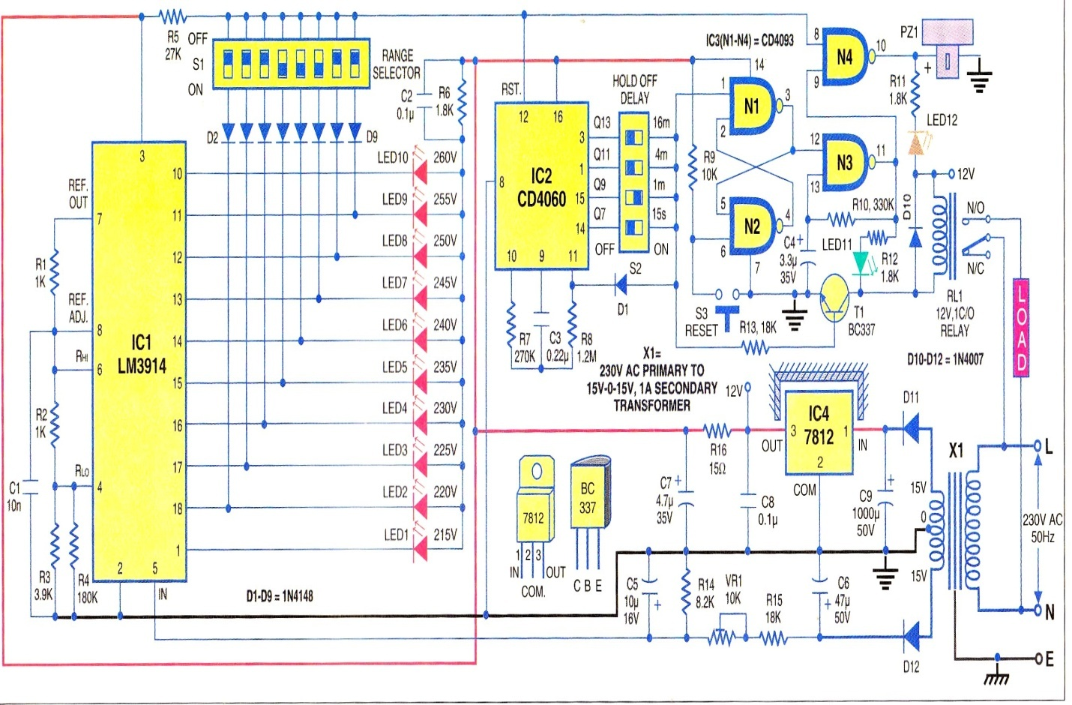

CIRCUIT DESCRIPTION

Fig shows the mains monitor circuit. The circuit is built around LM3914 dot/bar LED driver (IC1), CD4060 timer/counter (IC2), CD4093 quad Schmitt NAND gate (IC3) and a few discrete components. At the heart of the circuit is LM3914 dot/bar display driver, which drives ten LEDs in response to the input DC voltage from the secondary coil of transformer XI. This input voltage changes in proportion to the mains voltage (say, 240V). The -dot-mode LED display gives a direct readout of the incoming mains voltage.
The logic output of IC1 in response to the incoming voltage is used to control timer CD4060 (IC2) and relay RL1. IC CD4093 functions as an event memory latch with NAND gates N1 and N2. A 1Hz oscillator is built around NAND gate N3
To derive the power supply for the circuit, the-230V AC mains is stepped down by transformer XI to deliver a secondary output of 15V-0-15V, 1A. The transformer output is rectified by two separate half-wave rectifier diodes D11 and D12. The rectified output from diode D11 is filtered by capacitor C9 and regulated by IC 7812 (IC4). Capacitor C8 bypasses the ripples present in the regulated supply. The filter stage made of resistoR.R16 and capacitor C7 provides a clean DC supply to the circuit.
The rectified output of diode D12 is used to monitor the mains voltage level. It is filtered by capacitor C6 and applied to an adjustable voltage divider formed by resistor R15, preset VR1 and resistor R14. The adjustable voltage divider output is filtered by capacitor C5 and fed to input pin 5 of IC1. The voltage divider formed by resistors R1 through R4 makes IC1 act as a voltmeter. LED1 through LED10 glow as the input voltage at pin 5 of IC1 increments. Using resistors R1 through R4, IC1 is set to display 215V AC and 260V AC on LED1 and LED10, respectively. Pin 9 of IC1 is left open to make it run in 'dot' mode. Resistor R6 limits the current through LEDs.
Pins 11 through 18 of IC1 are coupled to diodes D2 through D9. Diodes D2 through D9, DIP switch SI and pull-up resistor R5 form an AND gate at the junction of resistor R5 and DIP switch SI. If the voltage-range selector DIP switches connected to D5, D6 and D7 are closed, the AND gate output will be low and LED5, LED6 and LED7 glow to indicate that the mains voltage ranges between 235V and 245V —the acceptable voltage range. Conversely, the AND gate output" goes high when the mains voltage is outside this range, as one of the other LM3914 outputs will be low. This AND gate output controls reset pin 12 of timer IC2 and LED12 through NAND gate N4.

Timer IC2 is enabled when mains voltage is within the predefined range but resets when the mains voltage goes out of the acceptable limit. Resistors R7 and R8, and capacitor C3 run the internal oscillator of IC2 so that outputs Q7, Q9, Q11 and Q13 provide a time delay of 15 seconds, 1 minute, 4 minutes and 16 minutes, respectively.
These four outputs are applied to hold-off delay switch S2 (DIP switch), which selects any one input and provides it to diode D1. Assuming DIP switch S2 selects Q9 output of IC2, Q9 output goes high after a delay of around one minute to disable the clock circuit of CD4060 via diode D1. As a result, the counter stops counting with the selected output held high and remains in this condition until it is reset by the OR gate output. The high output of DIP switch S2 energises relay RL1 via resistor R13 and transistor T1, and the AC mains source connects to. the load through relay contacts.
The high output of DIP switch S2 is also applied to the set input of the event memory latch —a negative-edge-triggered flip-flop made of NAND gates N1 and N2. This flip-flop can be reset by pressing memory reset switch S3. frequency of oscillations is around 1 Hz. The oscillator is normally in disabled state as the collector of transistor T1 is low when the mains voltage is within the acceptable range (indicated by glowing of LED11).
When AC mains is within the acceptable range (set by using DIP switch SI), the AND gate output is low, gate N4 output is high and LED12 is off. In short, when the AND gate output is low, the event memory flip-flop resets and relay RL1 energises to connect mains power to the load.
When the mains voltage goes outside the acceptable range, the resulting high level on the OR gate resets IC2 (making all of its outputs low). Transistor T1 cuts off and relay RL1 de-energises to disconnect the load from the mains and set the event flip-flop. The high output of the flip-flop enables the oscillator, which provides 1Hz clock pulse to gate N4. LED12 flashes when the gate is enabled by the OR gate output.
LED11 is off, as the collector of transistor T1 is high. LED12 flashes and LED11 remains off until the mains voltage returns to the acceptable value. When mains power returns to the acceptable voltage, LED12 is disabled and timer IC2 enabled. IC2 starts oscillating to advance the counter. The count keeps incrementing until timer IC2 output goes high (selected by DIP switch S2) after the hold-off delay (time taken to connect the load to mains power after mains power returns to the acceptable voltage).
Output Q9 of CD4060 goes high after hold-off delay of one minute and most of the circuit returns to normal state as detailed above. However, setting the event flip-flop during mains voltage outside the acceptable range leaves the oscillator enabled. As a result, LED11 flashes at 1 Hz, which also indicates that a mains fluctuation has occurred. Switch S3 resets the flip-flop, returning the circuit to its normal state

LM3914

Features
• Drives LEDs, LCDs or vacuum fluorescents
• Bar or dot display mode externally selectable by user
• Expandable to displays of 100 steps
• Internal voltage reference from 1.2V to 12V
• Operates with single supply of less than 3V
• Inputs operate down to ground
• Output current programmable from 2 mA to 30 mA
• No multiplex switching or interaction between outputs
• Input withstands ±35V without damage or false outputs
• LED driver outputs are current regulated, open-collectors
• Outputs can interface with TTL or CMOS logic
• The internal 10-step divider is floating and can be referenced to a wide range of voltages

DESCRIPTION

The LM3914 is a monolithic integrated circuit that senses analog voltage levels and drives 10 LEDs, providing a linear analog display. A single pin changes the display from a moving dot to a bar graph. Current drive to the LEDs is regulated and programmable, eliminating the need for resistors. This feature is one that allows operation of the whole system from less than 3V.
The circuit contains its own adjustable reference and accurate 10-step voltage divider. The low-bias-current input buffer accepts signals down to ground, or V-, yet needs no protection against inputs of 35V above or below ground. The buffer drives 10 individual comparators referenced to the precision divider. Indication non-linearity can thus be held typically to ½%, even over a wide temperature range.
Versatility was designed into the LM3914 so that controller, visual alarm, and expanded scale functions are easily added on to the display system. The circuit can drive LEDs of many colors, or low-current incandescent lamps. Many LM3914s can be "chained" to form displays of 20 to over 100 segments. Both ends of the voltage divider are externally available so that 2 drivers can be made into a zero-center meter.

The LM3914 is very easy to apply as an analog meter circuit. A 1.2V full-scale meter requires only 1 resistor and a single 3V to 15V supply in addition to the 10 display LEDs. If the 1 resistor is a pot, it becomes the LED brightness control. The simplified block diagram illustrates this extremely simple external circuitry.
When in the dot mode, there is a small amount of overlap or "fade" (about 1 mV) between segments. This assures that at no time will all LEDs be "OFF", and thus any ambiguous display is avoided. Various novel displays are possible.
Much of the display flexibility derives from the fact that all outputs are individual, DC regulated currents. Various effects can be achieved by modulating these currents. The individual outputs can drive a transistor as well as a LED at the same time, so controller functions including "staging" control can be performed. The LM3914 can also act as a programmer, or sequencer.
The LM3914 is rated for operation from 0°C to +70°C. The LM3914N-1 is available in an 18-lead molded (N) package.

CD4060
IC 4060 is an Oscillator binary counter cum frequency divider. Its inbuilt oscillator is based on three inverters. The basic frequency of the internal oscillator is determined by the value of the capacitor connected to its pin 9 and that of the resistor in its pin 10. By increasing or decreasing the value of capacitor / resistor, time delay can be changed. Each output goes high after the completion of the timing cycle. Inside the IC, there is an
oscillator and 14 series connected bitable (Ripple cascade arrangement). Internally the oscillator signal is applied to the first bistable which drives the second bistable and so on. Since each bistable divides its input signal by two, a total of fifteen signals are available, each of half the frequency of the previous one.
Ten of these fifteen signals are available on the output pins Q3- Q13.HEF 4060 is CMOS version which can operate at 3 volts while CD 4060 is high voltage type that can operate between 5 to 15 volts. It is necessary to add a capacitor close to pin 16 of IC so that minute voltage changes will not affect the timing cycle. Reset pin 12 resets the timing cycle once it is grounded. Outputs can give almost full supply voltage to drive light loads. Heavy loads such as relay can be operated through a driver transistor. When the high output is connected to the pin 11(clock input) through a diode, oscillation stops and IC remains latched in high state till it resets. Pin 11 can be used to give clock pulses from an external source.

Timing cycle calculation
Time t = 2 n / f osc =Seconds
n is the selected Q output number
2 n = Q output number = 2 x Q no times Eg. Q3 output = 2x2x2 = 8
f osc = 1 / 2.5 (R1xC1) = in Hertz
R1 is the resistor at pin 10 in Ohms and C1, the capacitor at pin 9 in Farads.
For example if R1 is 1M and C1 0.22, the basic frequency f osc is
1 / 2.5(1,000,000 x 0.000,000 22) = 1.8 Hz
If the selected output is Q3 then 2 n is 2 x 2 x 2 = 8
Therefore time period (in seconds) is
t = 2 n / 1.8 Hz = 8 / 1.8 = 4.4 seconds

A ready reckoner for selecting the output to get a required time delay is given along

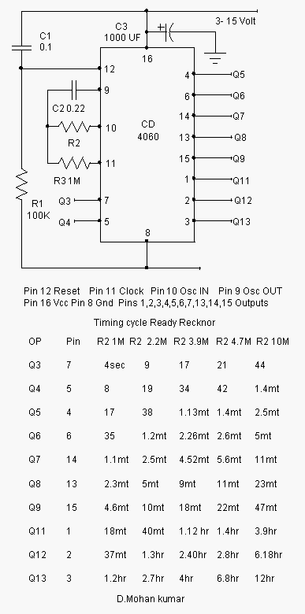 the diagram

LM78XX Series Voltage Regulators
General Description
The LM78XX series of three terminal regulators is available with several fixed output voltages making them useful in a wide range of applications. One of these is local on card regulation, eliminating the distribution problems associated with single point regulation. The voltages available allow these Regulators to be used in logic systems, instrumentation, HiFi, and other solid state electronic equipment. Although designed primarily as fixed voltage regulators these devices can be used with external components to obtain adjustable voltages and currents. The LM78XX series is available in an aluminum TO-3 package which will allow over 1.0A load current if adequate heat sinking is provided. Current limiting is included to limit the peak output current to a safe value. Safe area protection for the output transistor is provided to limit internal power dissipation. If internal power dissipation becomes too high for the heat sinking provided, the thermal shutdown circuit takes over preventing the IC from overheating. Considerable effort was expanded to make the LM78XX series of regulators easy to use and minimize the number of external components. It is not necessary to bypass the output, although this does improve transient response. Input bypassing is needed only if the regulator is located far from the filter capacitor of the power supply.

ADVANTAGES

- Fully automatic working
- Can retain voltage fluctuation by turning off high load appliances
- Prevent damage to appliances and equipments connected to supply mains
- Range and time delay can be set by user

DISADVANTAGES

- No LCD display to indicate voltage level
- Interruption in supply occurs when voltage goes out of range

FUTURE SCOPE

- LCD display to show voltage level
- Time at which voltage fluctuation occurs can be indicated

APPLICATIONS

- Devices which are sensitive to voltage fluctuations can be effectively plugged in to the circuit for protection
- Domestic & industrial applications

CONCLUSION

The aim of our project was to design a circuit which prevents damage to appliances connected to supply mains during voltage fluctuations. Circuit consists of the following sections ie. Power Supply Section, LED Display Section , Timer Section and NAND Gate Section. Relay is also placed at the end for switching action . The circuit has been tested and each section works efficiently. The final output was also obtained . It can be operated in days as well as night.

REFERENCES

WEBSITES
www.electronicsforu.com
www.datasheetcatalog.com
www.wikipedia.com

TEXTBOOKS
Electronics for you magazine

